- write a python program that accepts user input (name and age),prints a formatted message and displays the data type of each input.
# Accept user input
name = input("Enter your name: ")
age = input("Enter your age: ")

# Print formatted message
print(f"Hello {name}, you are {age} years old.")

# Display data types
print("Data type of name:", type(name))
print("Data type of age:", type(age))

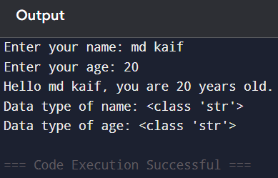

- Develop a python program that takes a number as input and determines whether it is positive,negative,or zero.

# Program to check whether a number is positive, negative, or zero

num = float(input("Enter a number: "))

if num > 0:
print("The number is Positive")
elif num < 0:
print("The number is Negative")
else:
print("The number is Zero")
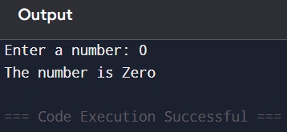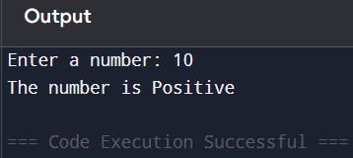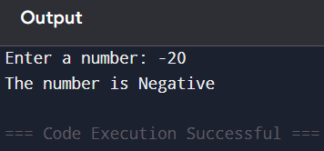
- Create a python program to calculate sum the of the first N natural numbers using a loop.
# Program to calculate the sum of first N natural numbers

n = int(input("Enter the value of N: "))

sum = 0

for i in range(1, n + 1):
sum = sum + i

print("The sum of first", n, "natural numbers is:", sum)

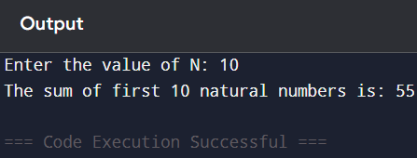

- Write a program demonstrating the use of arithmetic ,comparison and logical operators.

# Program demonstrating arithmetic, comparison, and logical operators

a = int(input("Enter first number: "))
b = int(input("Enter second number: "))

# Arithmetic Operators
print("\nArithmetic Operators:")
print("Addition =", a + b)
print("Subtraction =", a - b)
print("Multiplication =", a * b)
print("Division =", a / b)
print("Modulus =", a % b)

# Comparison Operators
print("\nComparison Operators:")
print("a == b :", a == b)
print("a != b :", a != b)
print("a > b :", a > b)
print("a < b :", a < b)
print("a >= b :", a >= b)
print("a <= b :", a <= b)

# Logical Operators
print("\nLogical Operators:")
print("(a > 0 and b > 0) :", (a > 0 and b > 0))
print("(a > 0 or b > 0) :", (a > 0 or b > 0))
print("not(a > 0) :", not(a > 0))

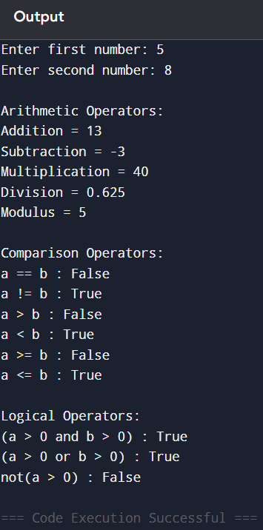

5.write a python program that reads a list of numbers from the user , finds the maximum , minimum , and sum , and sorts the list.
# Program to find maximum, minimum, sum, and sort a list

# Read numbers from the user
numbers = list(map(int, input("Enter numbers separated by space: ").split()))

# Find maximum, minimum, and sum
maximum = max(numbers)
minimum = min(numbers)
total = sum(numbers)

# Sort the list
numbers.sort()

# Display results
print("Maximum number:", maximum)
print("Minimum number:", minimum)
print("Sum of numbers:", total)
print("Sorted list:", numbers)

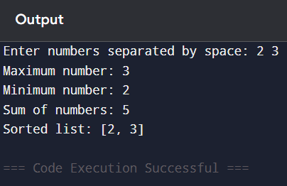

6.Develop a python program that accepts a string and performs multiple operations such as counting vowels,reversing the string ,and checking for palindrome.
# Program to perform string operations

# Accept a string from the user
text = input("Enter a string: ")

# Count vowels
vowels = "aeiouAEIOU"
count = 0

for ch in text:
if ch in vowels:
count += 1

# Reverse the string
reverse_text = text[::-1]

# Check palindrome
if text == reverse_text:
palindrome = True
else:
palindrome = False

# Display results
print("Number of vowels:", count)
print("Reversed string:", reverse_text)

if palindrome:
print("The string is a Palindrome")
else:
print("The string is not a Palindrome")
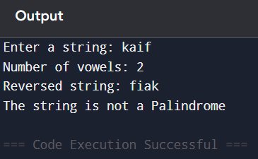

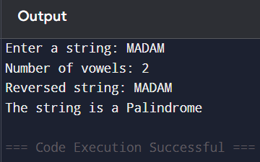

7.Write a python program using functions to perform operations like factorial and Fibonacci sequence.
# Program to find Factorial and Fibonacci sequence using functions

# Function to calculate factorial
def factorial(n):
fact = 1
for i in range(1, n + 1):
fact = fact * i
return fact

# Function to print Fibonacci sequence
def fibonacci(n):
a = 0
b = 1

print("Fibonacci sequence:")

for i in range(n):
print(a, end=" ")
c = a + b
a = b
b = c

# Main program
num = int(input("Enter a number: "))

# Factorial
print("Factorial =", factorial(num))

# Fibonacci
fibonacci(num)
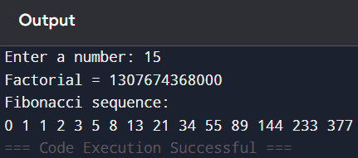

8.Create a program that uses dictionaries to store student names and marks , then finds and displays the highest and lowest scorer.
# Program to store student names and marks using dictionary
# and find the highest and lowest scorer

students = {}

n = int(input("Enter number of students: "))

for i in range(n):
name = input("Enter student name: ")
marks = float(input("Enter marks: "))
students[name] = marks

# Finding highest scorer
highest_student = max(students, key=students.get)

# Finding lowest scorer
lowest_student = min(students, key=students.get)

print("\nStudent Records:")
print(students)

print("\nHighest Scorer:")
print(highest_student, "-", students[highest_student])

print("\nLowest Scorer:")
print(lowest_student, "-", students[lowest_student])

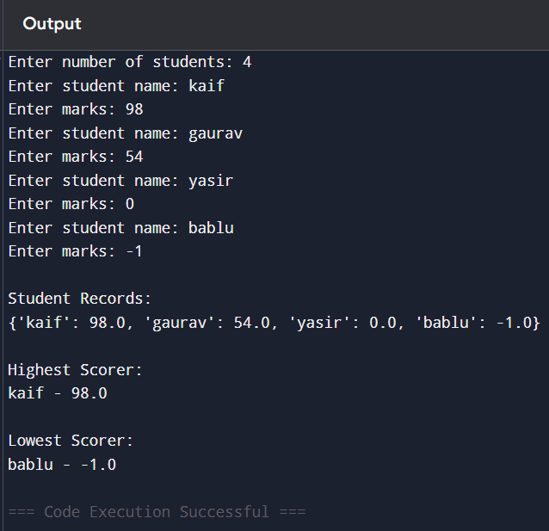

9.Write a python program that reads data from a file,processes the content (such as counting words and lines),and handles possible errors using exception handling.
# Python program to read data from a file,
# count lines and words, and handle errors using exception handling

try:
# Open the file in read mode
file = open("sample.txt", "r")

# Read file content
content = file.read()

# Count lines
lines = content.split('\n')
line_count = len(lines)

# Count words
words = content.split()
word_count = len(words)

# Display results
print("File Content:\n")
print(content)

print("\nNumber of lines:", line_count)
print("Number of words:", word_count)

# Close the file
file.close()

except FileNotFoundError:
print("Error: File not found.")

except PermissionError:
print("Error: Permission denied to access the file.")

except Exception as e:
print("An unexpected error occurred:", e)

